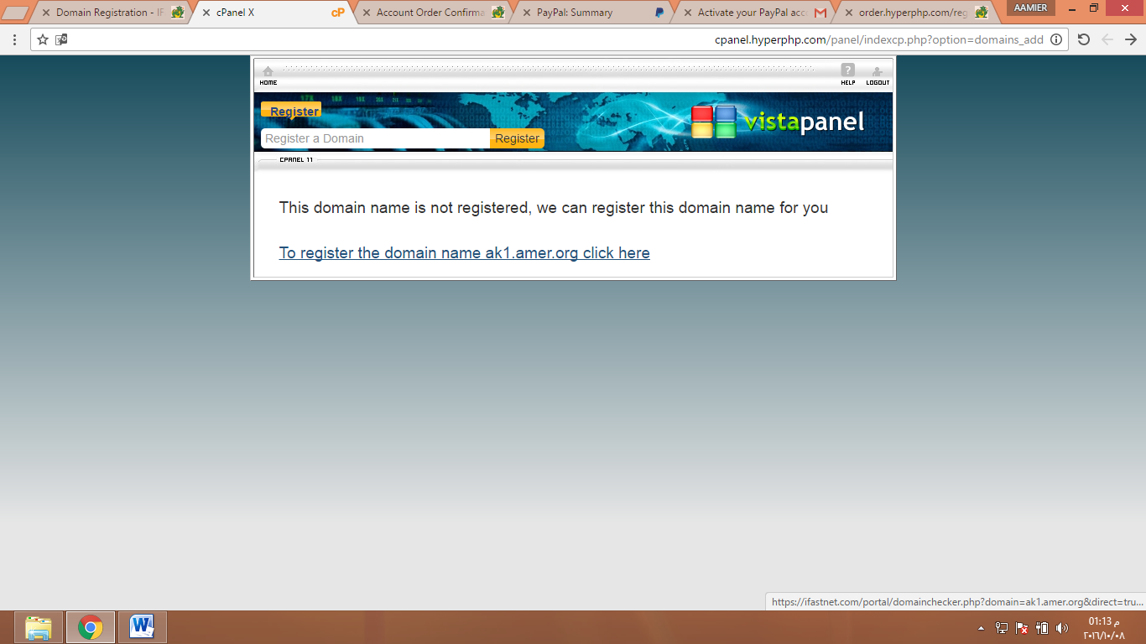 [venue90.net23.net](http://venue90.net23.net/)

**Your Account Details**  
Your account is now active.

|  |  |
| --- | --- |
| **Main Hosting Details** | |
| Control panel username | **hp_18039186** |
| Control panel password | **\*\*\*\*\*\*\*\*\*\*** |
| Control panel URL | [**cpanel.hyperphp.com**](http://cpanel.hyperphp.com/) |
| MySQL username | **hp_18039186** |
| MySQL password | **\*\*\*\*\*\*\*\*\*\*** |
| MySQL hostname | **sql203.hyperphp.com** |
| FTP username | **hp_18039186** |
| FTP password | **\*\*\*\*\*\*\*\*\*\*** |
| FTP host name | **ftp.hyperphp.com** |
|  |  |
| **Your Website URL's** | |
| Home page | [http://amer90.hyperphp.com](http://amer90.hyperphp.com/) |

